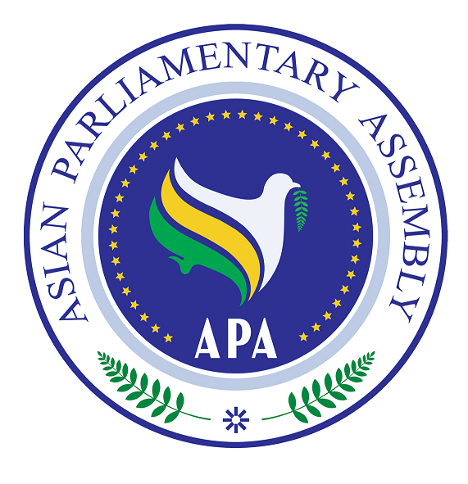

Statement by H.E. M.H. Nejad Hosseinian
The Secretary-General of the
Asian Parliamentary Assembly (APA)
Before
The Sixth Session of the PUIC Conference

Kampala, Uganda

30-31 January 2010

Mr. Secretary-General,
Ladies and Gentlemen,

It gives me a great pleasure to speak before the Sixth Session of the PUIC Conference. As we are meeting today, there are many challenges facing our regions which require our vigilance and commitment to address and find solution for them in an efficient manner. I would like to thank Dr. Edward Kiwanuka Ssekandi, the honorable Speaker of the Parliament of Uganda, as the Chairman of the Conference, and Dr. Mahmud Erol Kilic, the distinguished Secretary-General of PUIC for their kind invitation and warm hospitality.

Mr. Chairman,

The Asian Parliamentary Assembly was formally founded in 2006 in Tehran. The objective of establishing the APA is to fly together and bring about greater cooperation among Member Parliaments and ultimately greater integration in Asia. The APA Charter, extremely values this objective.

Mr. Chairman,

About half of APA Member Parliaments are also members of PUIC and there are common subjects in the agendas of the two organizations. These are indications that we can cooperate on most of issues for the benefit of the peoples in Asia and across the Muslim world. Therefore, PUIC and APA each can combine the potentials of their member parliaments to advance their programs and objectives.

The secretariats of both organizations may hold work shops to compare notes and exchange views and experience on how to improve organizational efficiency, assess member parliaments’ programs on capacity building for their parliamentarians and exchange information and best practices on those programs; develop creative strategies to promote parliamentary diplomacy, and to explore strategies to promote parliamentary influence policy formulation and implementation at national and international levels.

There are many common issues, particularly in the economic and social fields, that both organizations deal with. For instance, APA has worked hard to develop an Asian approach to managing the ramification of the current international financial crisis. PUIC has also dealt with this problem. The two organizations can exchange views on this urgent issue on how the potentials of Asia and Muslim world can be jointly utilized in order to alleviate the negative repercussions on the economies of members of both organizations.

Many issues of concern to the Islamic countries are also taken up by APA. In this context, one can refer to the question of Palestine where both PUIC and APA has engaged in political and public campaign against the atrocities being committed by Israel against the defenseless Palestinian people. The fact that the Emergency Item of the current PUIC Session is devoted to a unified position of OIC Member Parliaments in support of Palestine against aggression and war crimes committed by Israel in the occupied territories is an indication of the PUIC’s resolve to take necessary measures to confront the Israeli plans in the region.

APA has also taken specific measures to end the occupation of Palestine. Last year, the APA Troika composed of the Speakers of the Parliaments of Indonesia, the Islamic republic of Iran and the Syrian Arab Republic visited the countries neighboring Palestine and held meetings with the officials of those countries. They also met with the local and international media in the region to express Asian Parliaments’ support for the cause of Palestine. Along the same line, the Fourth APA Plenary Session, held last December in Indonesia, adopted a strong resolution on Palestine, and while condemning deliberate violations of international humanitarian law by the Israeli occupying forces in Gaza, called upon the Zionist regime, the occupying power, to withdraw from all the occupied territories including al-Quds al-Sharif, Gaza Strip and the West Bank, the Golan Heights, and Shaba lands.

Mr. Chairman,
Distinguished Colleagues,

Today’s complex world necessitates our concerted efforts to deal with numerous challenges facing all of us. APA and PUIC can cooperate to address the current international and regional issues and find solutions to them collectively. We are eager and ready to engage with PUIC on issues of common concern. I thank you, once more, for giving me the opportunity to speak to you today.

Thank you

