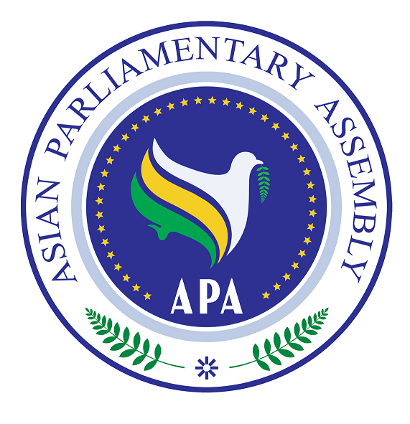

Statement by H.E. M.H. Nejad Hosseinian
The Secretary-General of the
Asian Parliamentary Assembly (APA)
Before
The 12th Meeting of the ICAPP Standing Committee

Kathmandu, Nepal

26-27 February 2010

Mr. Chairman,
Mr. Secretary-General,
Ladies and Gentlemen,
It is an honor for me to participate in the 12th Meeting of the ICAPP Standing Committee. I am thankful to Mr. Chung Eui-yong, the Co-Chairman of the Standing Committee and the Secretary-General of the ICAPP for the inclusion of an item to the agenda of this Standing Committee meeting, namely, “First Joint Session with the Executive Council of the APA” and for inviting me to share with you my thoughts on this important item.

Asia as a vast continent with rich mineral and human resources can find its rightful place in the world. Asia has great potentials to not only find solutions to its problems and enhance the well being of its population, but can also contribute to the advancement of the world economy. However, Asia still faces many challenges such as poverty, illiteracy, unemployment, malnutrition, severe health problems, environmental degradation and financial crisis. To this list, one can add the problems associated with the democratization process in Asia where APA and ICAPP can play a significant role to promote democracy in this continent.

Last September, I participated in the 5th ICAPP General Assembly meeting and touched upon the similarities between the objectives and the current agendas of APA and ICAPP. As two important organizations in Asia, we can work together to promote cooperation and friendship in Asia. We can also join forces to address and find solutions to the problems Asian countries face. One possible means for cooperation is the establishment of joint seminars or workshops on issues of interest to APA and ICAPP.
Mr. Chairman,
I believe the main objective of the cooperation between the two organizations should be to enhance integration in Asia. This can be accomplished, inter alia, through capacity building in elements of good governance. In this context, one can refer to issues like political freedom, promoting integrity of political system, accountability of political figures, combating corruption, public campaign and education on civil and political rights. Furthermore, we may discuss how the two organizations can jointly work towards the capacity building in codifying legislations in the above-mentioned areas.

In my opinion, the two organizations may decide to set up a joint working group to consider the following six broad areas of cooperation and come up with an agenda of the joint meeting of the ICAPP Standing Committee and the APA Executive Council which will be mutually reinforcing for their work:
- Granting observer status at each other's organization. At the moment, we have good line of communication between our two organizations. However, achieving observer status at each other's organization will provide us with better opportunities to exchange views and explore possibilities to find solutions to our common problems in Asia.
- Strengthening the role of Asian political parties in promoting integration in Asia. The objective of establishing the APA is to bring about greater integration in Asia. We can discuss how the Asian political parties can contribute to achieving this lofty goal.
- Improving the transparency and accountability of Asian political parties. There is no doubt that political parties should at all times possess a clean bill in different aspects of their work. In this respect, transparency and accountability of political parties are considered important elements for gauging their legitimacy and relevance. The two organizations can study how they can cooperate to create an atmosphere, in Asian countries, conducive to formulating laws on political parties which can make them more transparent and accountable.
- Cooperating on promoting the Declaration on Principles of Friendship and Cooperation in Asia. The Third APA Plenary in 2008 adopted this Declaration which is aimed at enhancing and strengthening friendship and cooperation among APA Member Parliaments. This Declaration can also play a pivotal role in the attainment of greater integration in Asia. APA and ICAPP can cooperate to promote this Declaration.
- Studying the possibility of developing common legislations or enabling national legislations for implementation of major international conventions in Asian parliaments. Agreeing about common legislations on common issues of interest is a first step towards bringing Asian parliaments closer. It also strengthens the hands of the parliaments to move towards greater integration in Asia. The two organizations may study different stages required for parliamentarians to agree on a common legislation. They may also discuss what issues to be considered as issues about which common legislations can be adopted. If the idea of arriving at common legislations seems to be far-fetched at this juncture, the two organizations may discuss how they can agree on general principles of major international conventions so as to enable national parliaments to implement those conventions.
- Promoting the ideas put forward by Asian Political parties among Asian parliaments. The political parties usually articulate their positions on issues of their interest before major elections. The APA may, through exchanges of views with the ICAPP, study those positions and consider how they can be promoted in APA Member Parliaments.

Mr. Chairman,
The above-mentioned points, along with other points the members of ICAPP Standing Committee propose, may be further developed in a 2-3 hour-brainstorming-meeting. I suggest that the joint meeting of the ICAPP Standing Committee and the APA Executive Council be held during the next APA Executive Council Meeting to be held in Jakarta in August 2010 or the 5th APA Plenary Meeting to be held in Syria in November 2010. In order to make our joint effort more formal, I will propose to the APA Executive Council to add an item to the agenda of its next meeting entitled "Cooperation between APA and ICAPP".
I am confident that with the enthusiasm and hard work put forward by both organizations to cooperate and address our common challenges, we can find solutions to the problems the Asian people face.
Thank you
APA/Res/2008/09/Annex
2٩ November 2008

Declaration on Principles of Friendship and Cooperation in Asia

We, the Members of the Asian Parliamentary Assembly,
Cognizant of the deep-rooted ties of history, geography, culture, and civilization which bind their peoples together;
Conscious of the shared challenges and opportunities facing the people of Asia as well as their common interests pointing to the need for further collaboration;
Being aware of the crucial role Asia plays in shaping the world future by reliance on its great human and natural resources, as well as its technological advancements;
Emphasizing the importance of regional arrangements for consolidation of ties among Asian countries in all fields;
Encouraging various methods of dialogue and peaceful interactions among Asian cultures and civilizations fostering cultural diversity and tolerance throughout the Asian continent;
Recognizing the constructive role of the Asian Parliamentary Assembly in paving the way for strengthening the amity and friendly relations among the people of Asia with reliance on commonalities of the Asian States in all areas;
Convinced that effective structures for cooperation among Asian countries could augment the benefits of globalization and diminish their harmful effects in Asia;
Committed to promote peace and security, at global as well as continental levels, on the bases of justice and the rule of law through expanding cooperation with all peace-loving nations within and outside Asia;
I. Unanimously declare our commitment to:
a) Promote permanent peace, enduring friendship and constructive cooperation among States and peoples of Asia;
b) Strengthen friendly relations among Asian States on the basis of equality and mutual respect;
c) Facilitate further advancement and sustainable development of all Asian
States in economic, social, scientific and technological fields;
d) Explore potential capabilities of all Asian States for expanding collaboration
in all areas of common interests.
II. To achieve the aforementioned purposes, the APA Member Parliaments shall be guided by the following fundamental principles:
a) Mutual respect to independence, territorial integrity and national
sovereignty of all states on the basis of non-interference in others internal
affairs;
b) The right of all Nations to self-determination;
c) Respect for fundamental human rights and human dignity;
d) Renunciation of the threat or use of force and the utilization of peaceful
means in international relations;
e) Cooperation on the basis of the rule of law.
III. In pursuance of the purposes of this Declaration, the APA Member Parliaments shall endeavor to develop and strengthen their traditional, cultural, economic and historical ties of friendship. In this respect, they shall support further expansion of diplomatic and commercial relations among their respective States and further communication and interaction among their peoples.
IV. Consistent with the provisions of the Chapter VIII of the United Nations Charter, the APA Member Parliaments shall encourage mutual confidence building measures through appropriate regional arrangements in order to promote peace and stability throughout Asia and in the World.
V. The APA Member Parliaments shall encourage collaboration within the United Nations to promote the role of Asia in the world community.
VI. The APA Member Parliaments shall uphold cooperation with all Parliaments in Asia, on the bases of the purposes and principles of this Declaration, towards the ultimate goal of establishing an Asian Parliament.
VII. The APA Member Parliaments shall collaborate for the acceleration of the economic growth in Asia. To this end, they shall promote greater utilization of capabilities in research and development, exchange of information, transfer of technology and foreign investment, towards a viable and sustainable growth.
VIII. The APA Member Parliaments shall intensify their concerted efforts in combating illiteracy, poverty, and environmental degradation. For this purpose, they shall support appropriate strategies at continental and regional levels for the mutual benefit of all Asian countries.
IX. To promote and consolidate peace in Asia, the APA Member Parliaments shall encourage inter-faith and inter-cultural dialogue among Asian civilizations.
X. To strengthen economic and commercial relations among Asian States, the APA Member Parliaments shall support appropriate measures to create an integrated energy market in Asia.
XI. The APA Member Parliaments shall provide for the exchange of information and experiences pertinent to reducing damages and alleviating the trauma inflicted by natural disasters.
XII. The APA Member Parliaments shall collaborate in eradicating all roots of terrorism and other organized crimes in order to make a strong and secure community of nations in Asia.
XIIV. The APA Member Parliaments shall intensify their efforts through bilateral and multilateral modalities in combating all sorts of illegal trafficking including the illegal trafficking of human beings, goods, weapons, and drugs.
XIV. Denouncing all sorts of aggression and foreign occupation, the APA Member Parliaments shall disapprove any activity in the territories of their respective States that would constitute a threat or use of force against the security, national sovereignty and territorial integrity of other APA Member Parliaments.
XV. The APA Member Parliaments shall maintain regular contacts and consultations with one another on international and regional matters in order to harmonize their views, actions and policies.

